**Local Host Test**

Creating mentor:

Endpoint: http://localhost:3000/mentors

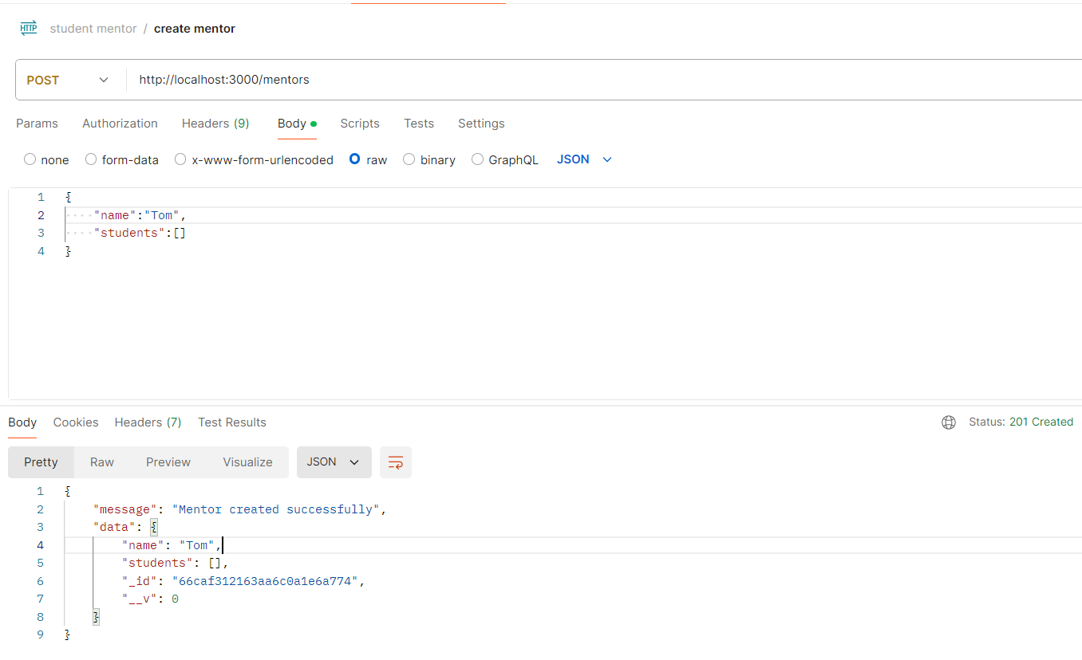

Creating student

Endpoints: <http://localhost:3000/students>

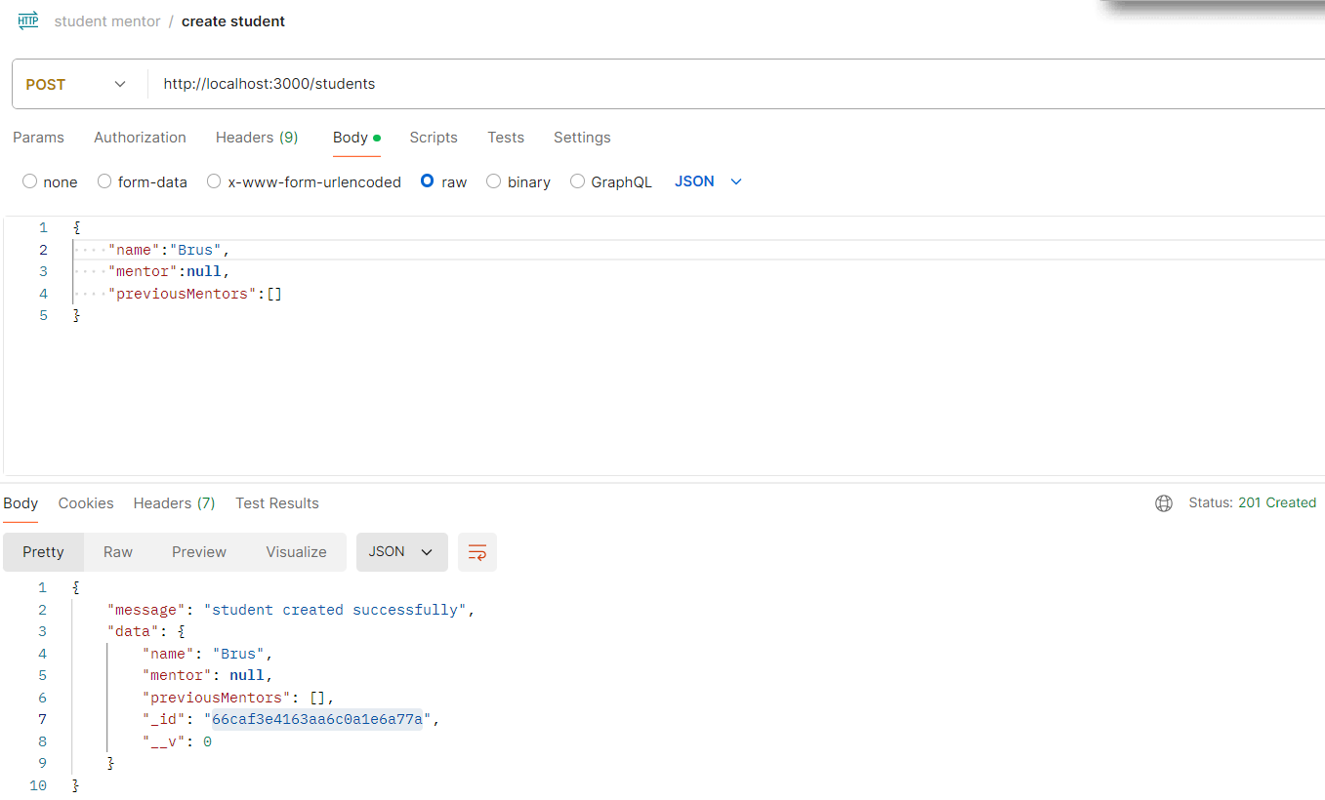

Assign a student to mentor

Endpoint: <http://localhost:3000/mentors/:mentorId/students/:studentId>

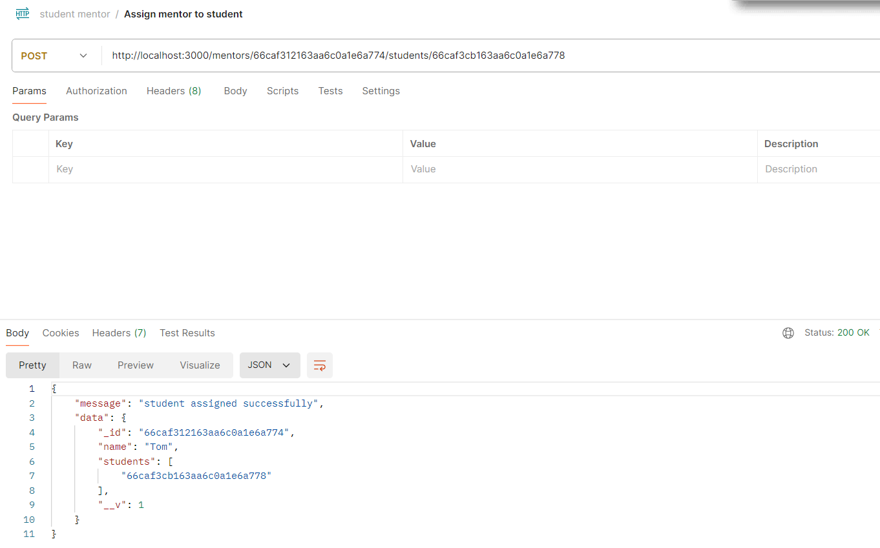

Change mentor to student

Endpoint: <http://localhost:3000/students/:studentId/mentor/:mentorId>

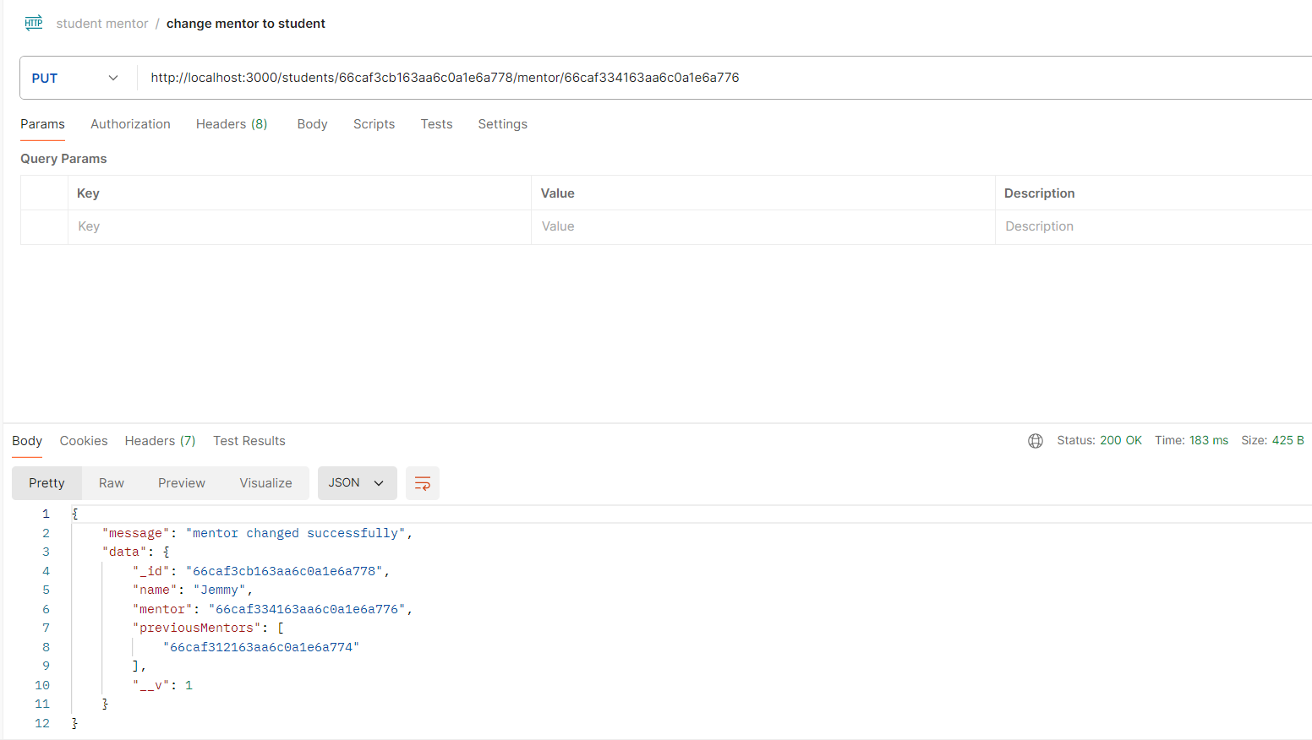

Get all students under a mentor given

Endpoint: <http://localhost:3000/mentors/:mentorId/students>

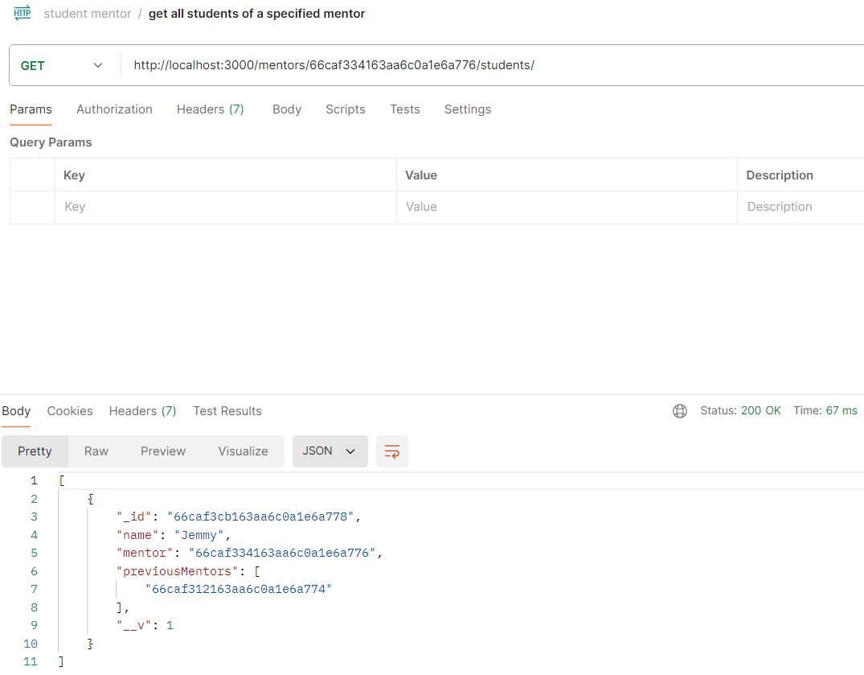

Get previous mentor assigned to the particular student

Endpoint: <http://localhost:3000/students/:studentId/previous-mentors>

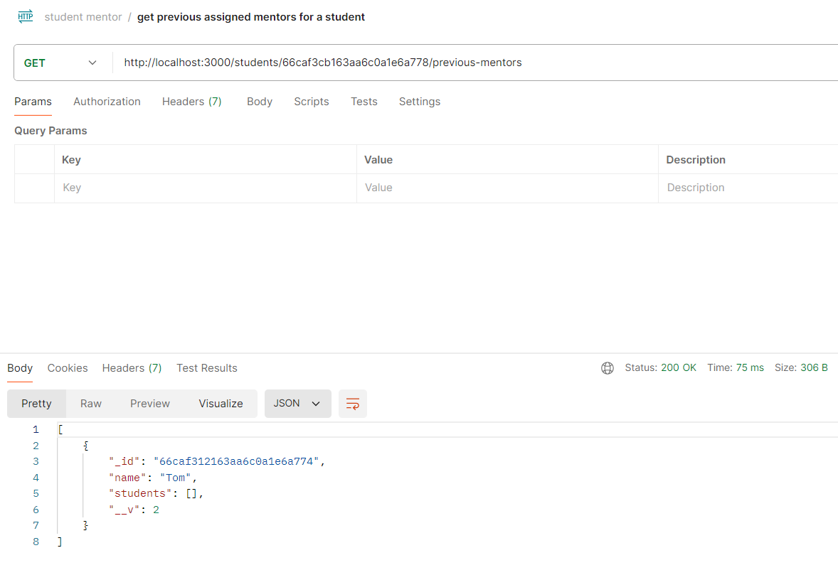

**Test after deployment**

Create mentor

Endpoint: https://studentmentorapi-g4jd.onrender.com/mentors

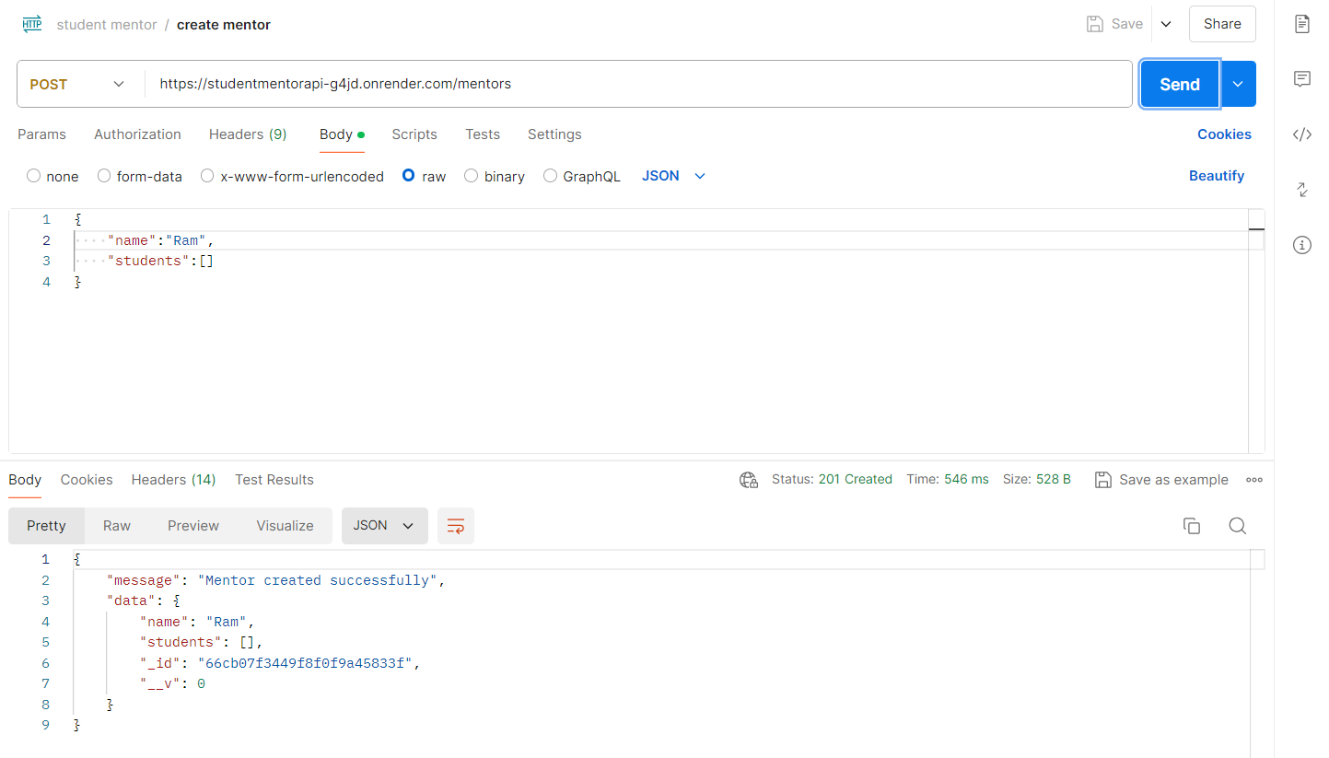

Create student

Endpoint: https://studentmentorapi-g4jd.onrender.com/students

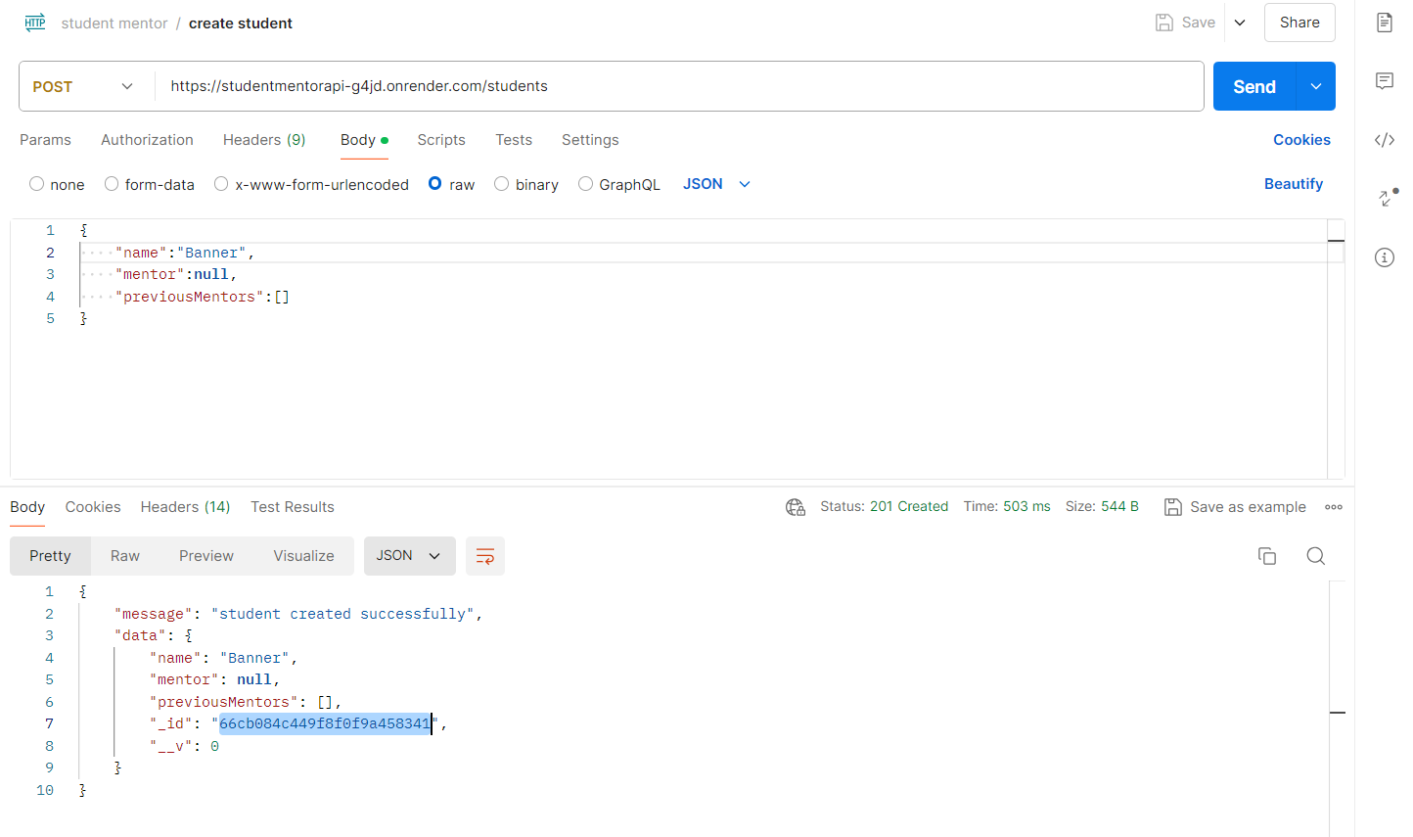

Assign student to mentors

Endpoint: <http://localhost:3000/mentors/:mentorId/students/:studentId>

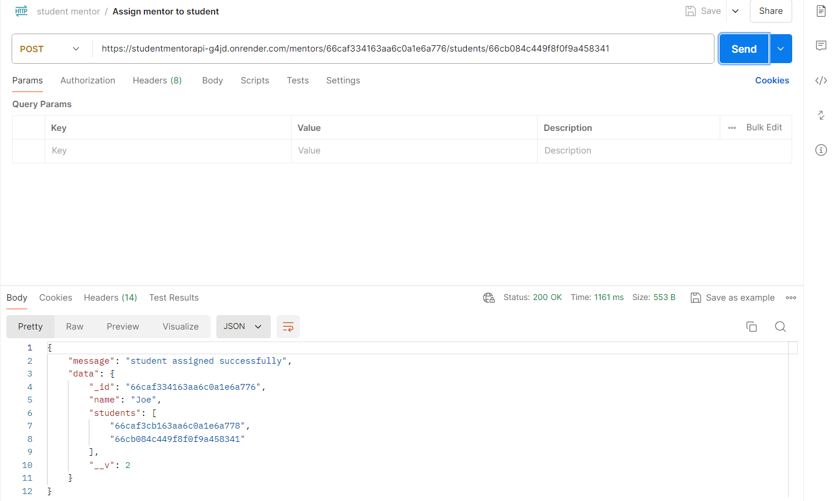

Throw message if student already have mentor

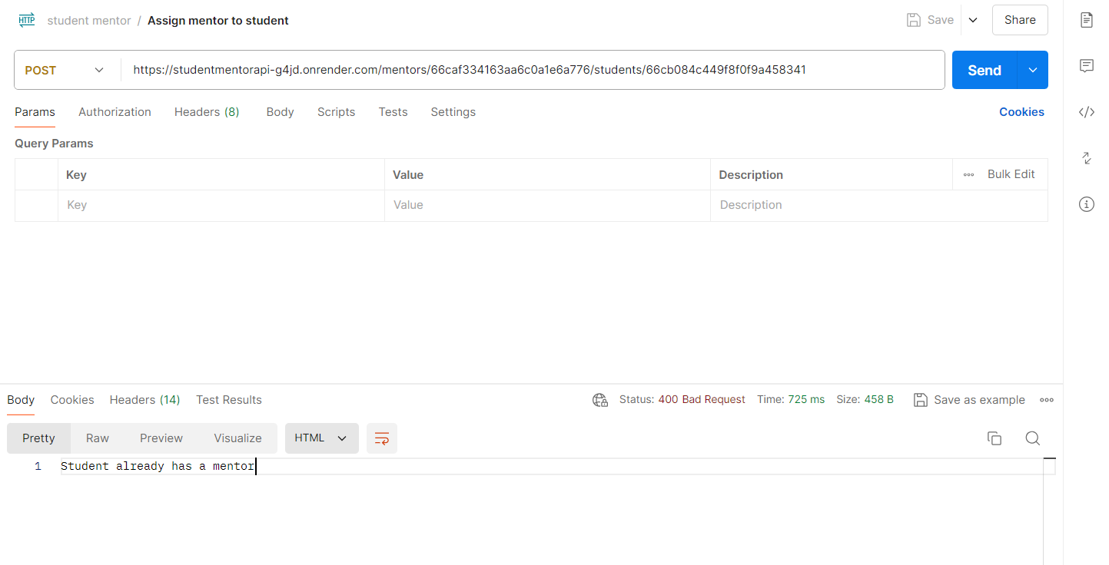

Change mentor for specified student

Endpoint: <http://localhost:3000/students/:studentId/mentor/:mentorId>

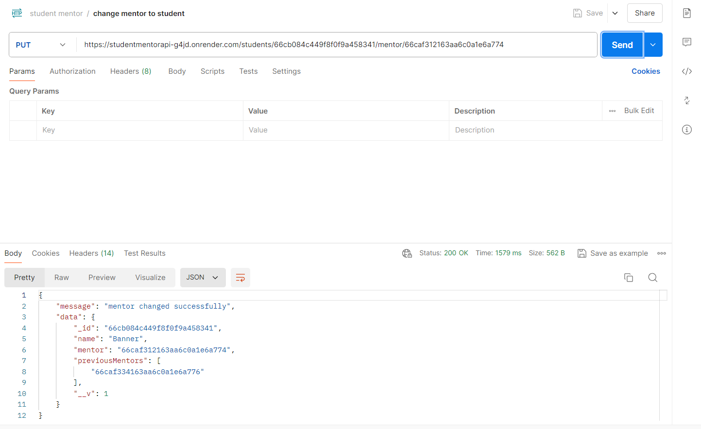

Get all students under a mentor given

Endpoint: <http://localhost:3000/mentors/:mentorId/students>

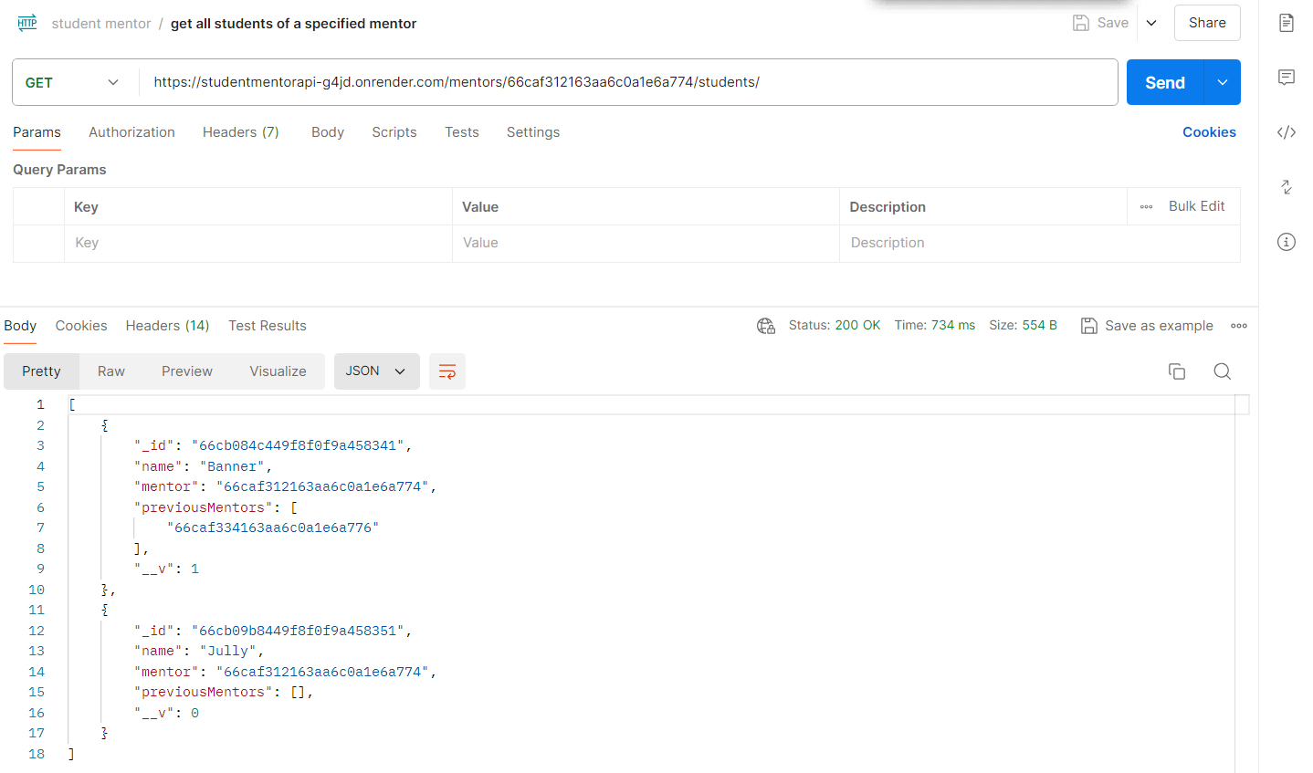

Get previous mentor assigned to the particular student

Endpoint: <http://localhost:3000/students/:studentId/previous-mentors>

